20160816 TCT Servo Demo 1 (sweep)

Original Source: https://www.arduino.cc/en/Tutorial/Sweep

[TUTORIALS](https://www.arduino.cc/en/Tutorial/HomePage) > [Examples from Libraries](https://www.arduino.cc/en/Tutorial/LibraryExamples) > Servo > Sweep

## Sweep

Sweeps the shaft of a RC [servo motor](http://en.wikipedia.org/wiki/Servo_motor#RC_servos) back and forth across 180 degrees.

This example makes use of the Arduino [servo library](https://www.arduino.cc/en/Reference/Servo).

### Hardware Required

* Arduino or Genuino Board
* Servo Motor
* hook-up wires

### Circuit

Servo motors have three wires: power, ground, and signal. The power wire is typically red, and should be connected to the 5V pin on the Arduino or Genuino board. The ground wire is typically black or brown and should be connected to a ground pin on the board. The signal pin is typically yellow, orange or white and should be connected to pin 9 on the board.

click the images to enlarge

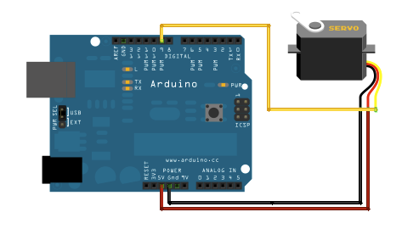

images developed using [Fritzing](http://www.fritzing.org/). For more circuit examples, see the [Fritzing project page](http://fritzing.org/projects/)

### Schematic

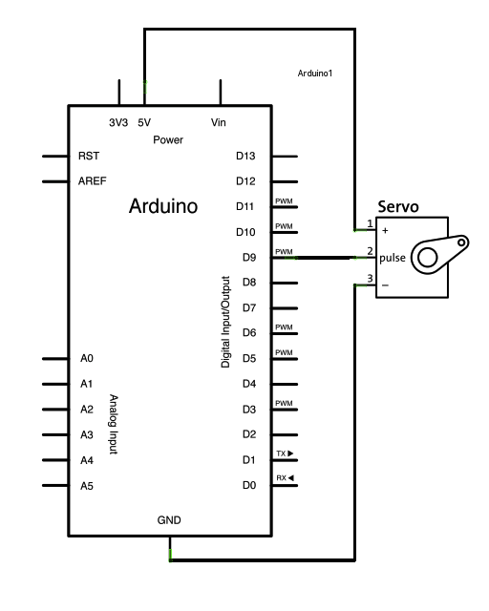

### Code

----------------------------------------------------------------------------------------------------

First Demo Code 8/16/2016

----------------------------------------------------------------------------------------------------

*/* Sweep*

*by BARRAGAN <http://barraganstudio.com>*

*This example code is in the public domain.*

*modified 8 Nov 2013*

*by Scott Fitzgerald*

*http://www.arduino.cc/en/Tutorial/Sweep*

*\*/*

#include <Servo.h>

Servo myservo; *// create servo object to control a servo*

*// twelve servo objects can be created on most boards*

int pos = 0; *// variable to store the servo position*

void **setup**() {

myservo.attach(9); *// attaches the servo on pin 9 to the servo object*

}

void **loop**() {

for (pos = 0; pos <= 180; pos += 1) { *// goes from 0 degrees to 180 degrees*

*// in steps of 1 degree*

myservo.write(pos); *// tell servo to go to position in variable 'pos'*

delay(15); *// waits 15ms for the servo to reach the position*

}

for (pos = 180; pos >= 0; pos -= 1) { *// goes from 180 degrees to 0 degrees*

myservo.write(pos); *// tell servo to go to position in variable 'pos'*

delay(15); *// waits 15ms for the servo to reach the position*

}

}